Data Communication and Network
LAB

FAROOQ AHMAD Experiment #10
17L4407 Lab Report # 9
BEE-5A

ANALYSIS OF DOMAIN NAME SYSTEM (DNS) PROTOCOL

INTRODUCTION
In this lab session, we were introduced to the analysis of domain name system (dns) protocol. Domain Name System (DNS) is the computer protocol that facilitates Internet communication using hostnames by matching an Internet Protocol (IP) address and a Fully Qualified Domain Name. Domain Name System (DNS) translates hostnames to IP addresses, fulfilling a critical role in the Internet infrastructure. The process of DNS resolution involves converting a hostname (such as www.example.com) into a computer-friendly IP address (such as 192.168.1.1). An IP address is given to each device on the Internet, and that address is necessary to find the appropriate Internet device.

OBJECTIVE

The course learning objective of this lab session was to introduce us to understand the term Domain Name System (DNS) and perform analysis on analysis of domain name system (dns) protocol.

DESIGN PROCEDURE
In the design procedure, we are going to have a closer look at the certain commands to analyze the domain name system (DNS).
nslookup
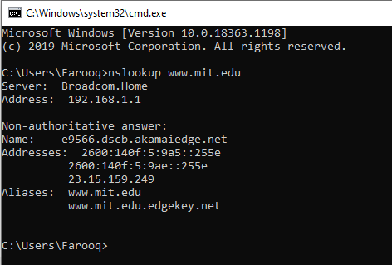

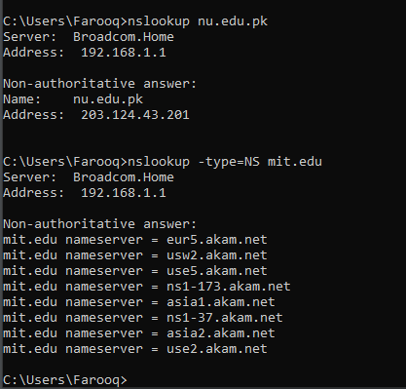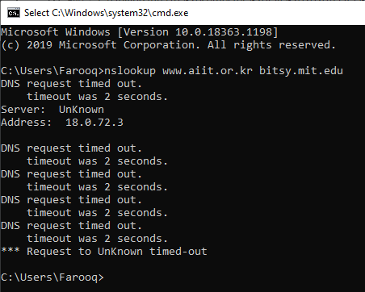

- Run nslookup to obtain the IP address of a Web server in Asia, e.g. www.lums.edu.pk. Paste screenshot of your result here:
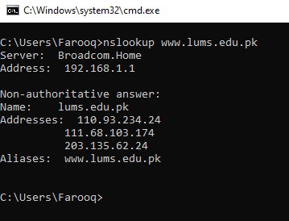

- Run nslookup to determine the authoritative DNS servers for a university in Europe (e.g., cam.ac.uk)
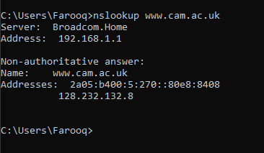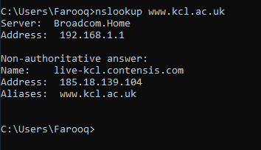
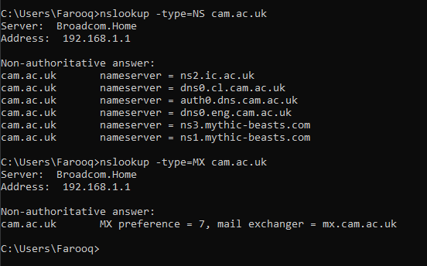
- Run nslookup so that one of the DNS servers obtained in Question 2 is queried for the mail servers for Yahoo! mail. If server does not respond, just type the command you used.
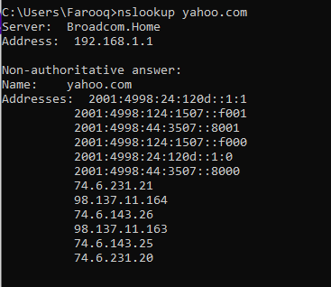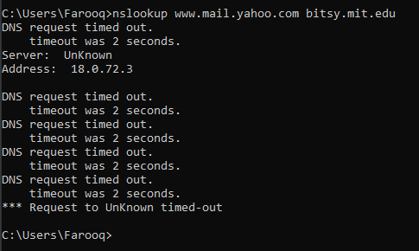

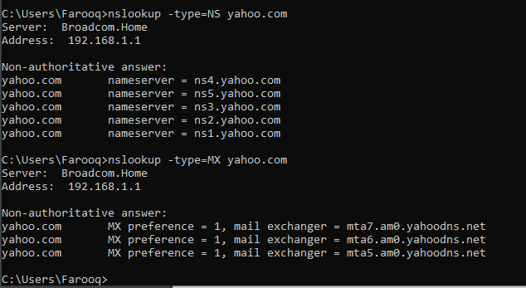

ipconfig
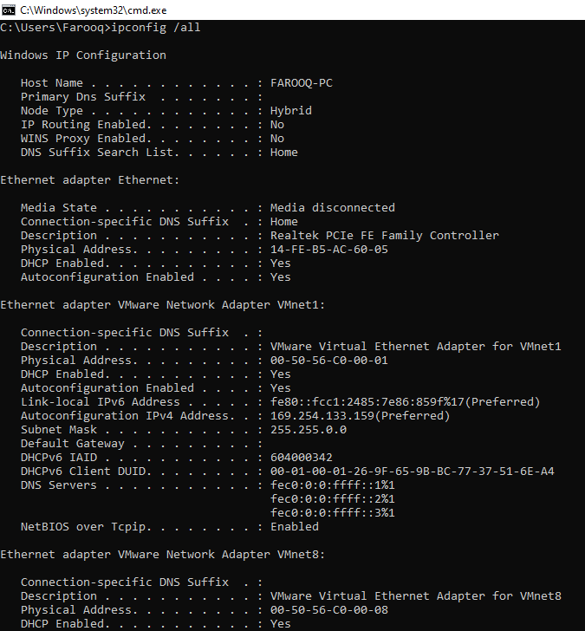

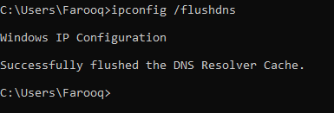
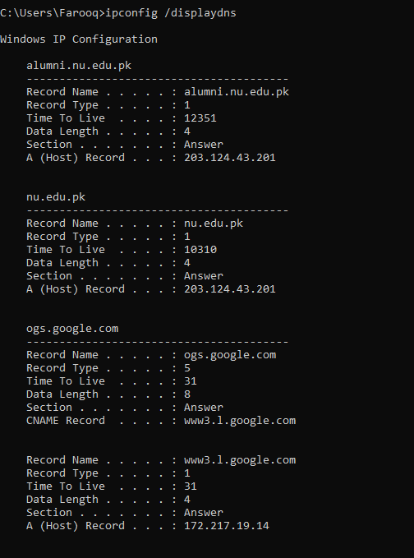

Tracing DNS with Wireshark

- Locate the DNS query and response messages. Are they sent over UDP or TCP?
UDP
- What is the destination port for the DNS query message? What is the source port of DNS response message?
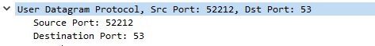
- To what IP address is the DNS query message sent? Use ipconfig to determine the IP address of your local DNS server. Are these two IP addresses the same?

- Examine the DNS query message. What “Type” of DNS query is it? Does the query message contain any “answers”?
Type A
no answers
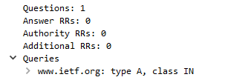
- Examine the DNS response message. How many “answers” are provided? What does each of these answers contain?
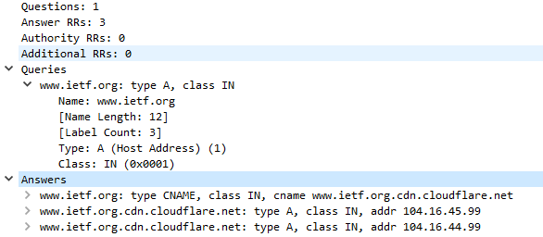

- Consider the subsequent TCP SYN packet sent by your host. Does the destination IP address of the SYN packet correspond to any of the IP addresses provided in the DNS response message?
Yes!

- This web page contains images. Before retrieving each image, does your host issue new DNS queries?
No!

Using a trace file

- What is the destination port for the DNS query message? What is the source port of DNS response message?
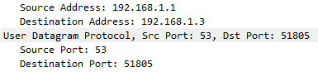

- To what IP address is the DNS query message sent? Is this the IP address of your default local DNS server?
Internet Protocol Version 4, Src: 192.168.1.3, Dst: 192.168.1.1
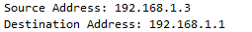
YES! This is the IP address of my default local DNS server.
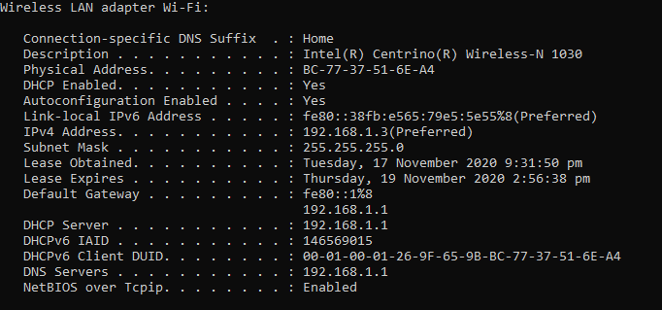

- Examine the DNS query message. What “Type” of DNS query is it? Does the query message contain any “answers”?

Type: A (Host Address) (1)
Answer RRs: 0

- Examine the DNS response message. How many “answers” are provided? What does each of these answers contain?
- Provide a screenshot.

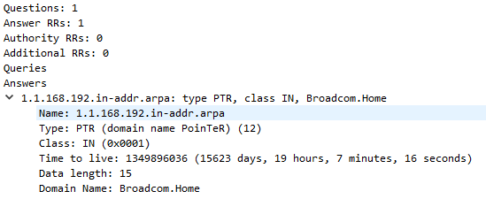

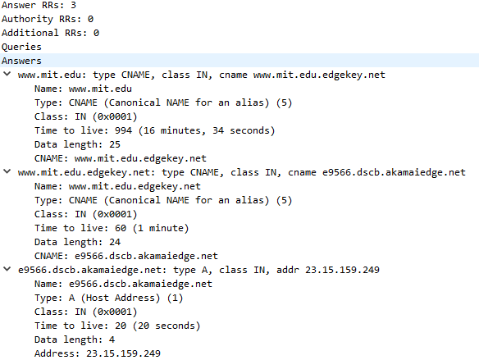

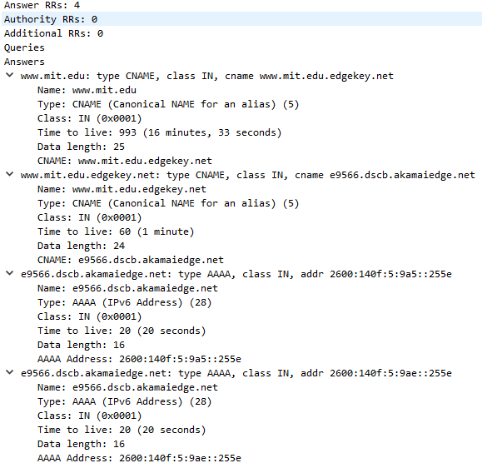

Now repeat the previous experiment, but instead issue the command:
nslookup –type=NS mit.edu

- To what IP address is the DNS query message sent? Is this the IP address of your default local DNS server?
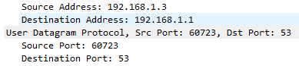
YES! This is the IP address of my default local DNS server.
- Examine the DNS query message. What “Type” of DNS query is it? Does the query message contain any “answers”?
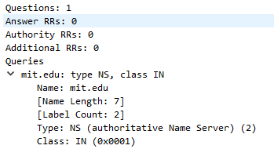
Type: NS (authoritative Name Server) (2)
Answer RRs: 0

- Examine the DNS response message. What MIT name servers does the response message provide? Does this response message also provide the IP addresses of the MIT name servers?
(authoritative Name Server) (2)
No!

- Provide a screenshot.
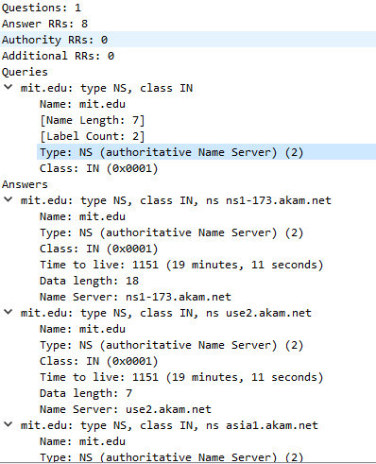

Now repeat the previous experiment, but instead issue the command:
nslookup www.aiit.or.kr bitsy.mit.edu

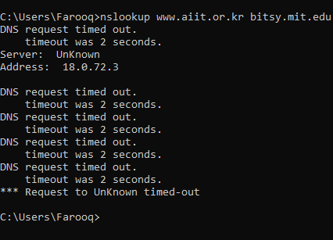
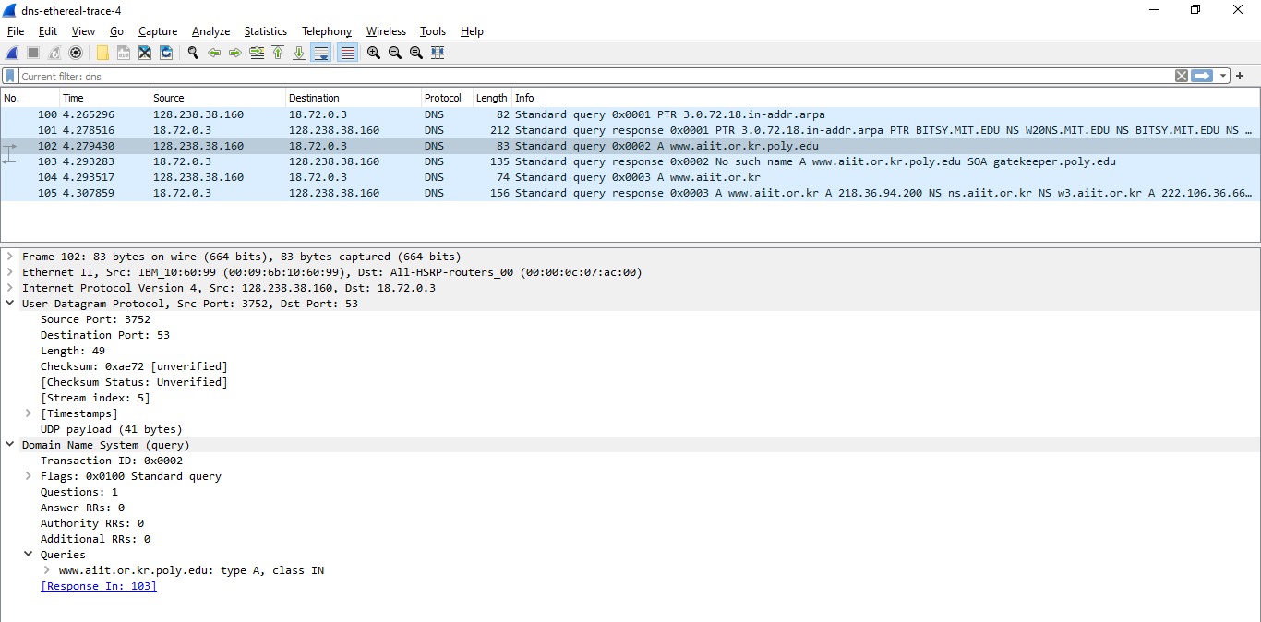

- To what IP address is the DNS query message sent? Is this the IP address of your default local DNS server? If not, what does the IP address correspond to?
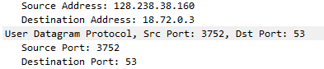
This is not the default dns server.
Destination Address: 18.72.0.3
Corresponds to bitsy.mit.edu.

- Examine the DNS query message. What “Type” of DNS query is it? Does the query message contain any “answers”?
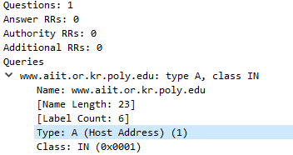
Type: A (Host Address) (1)
Answer RRs: 0

- Examine the DNS response message. How many “answers” are provided? What does each of these answers contain?
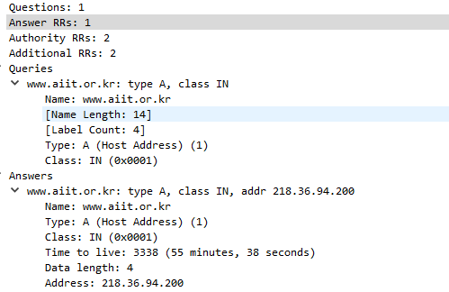

ISSUES
There were as such none issues.

CONCLUSION
This lab session was conducted successfully. The term Domain Name Protocol was understood and complete detailed analysis was performed on the domain name system (DNS) protocol. The Domain Network System (DNS) protocol helps Internet users and network devices discover websites using human-readable hostnames, instead of numeric IP addresses.

APPLICATIONS
The applications of domain name system dns protocol consists of the following
- A browser, application or device called the DNS client, issues a DNS request or DNS address lookup, providing a hostname such as “example.com”.
- The request is received by a DNS resolver, which is responsible for finding the correct IP address for that hostname. The DNS resolver looks for a DNS name server that holds the IP address for the hostname in the DNS request.
- The resolver starts from the Internet’s root DNS server, moving down the hierarchy to Top Level Domain (TLD) DNS servers (“.com” in this case), down to the name server responsible for the specific domain “example.com”.
- When the resolver reaches the authoritative DNS name server for “example.com”, it receives the IP address and other relevant details, and returns it to the DNS client. The DNS request is now resolved.
- The DNS client device can connect to the server directly using the correct IP address.

POST LAB
- Why does HTTP and DNS use TCP and UDP respectively?
HTTP uses TCP, as it needs to transmit entire files or data in one piece (reliability), and needs to maintain its connection (connection-oriented service). However, DNS uses UDP because it doesn’t need to maintain a constant connection, and there can be room for retransmissions in case of packet loss.
When HTTP wants to transmit a message, it streams the contents of the message data, in order, through an open TCP connection. TCP takes the stream of data, chops up the data stream into chunks called segments, and transports the segments across the Internet inside envelopes called IP packets
DNS uses the User Datagram Protocol (UDP) on port 53 to serve DNS queries. UDP is preferred because it is fast and has low overhead. A DNS query is a single UDP request from the DNS client followed by a single UDP reply from the server
- If the webpage having 10 reference objects and base html located at different location, then how may HTTP and DNS request will be generated?

One HTTP GET request will be generated to retrieve the base HTML file, which will have those 10 references, and then 10 DNS requests will be generated, which would be associated with the 10 references present.

